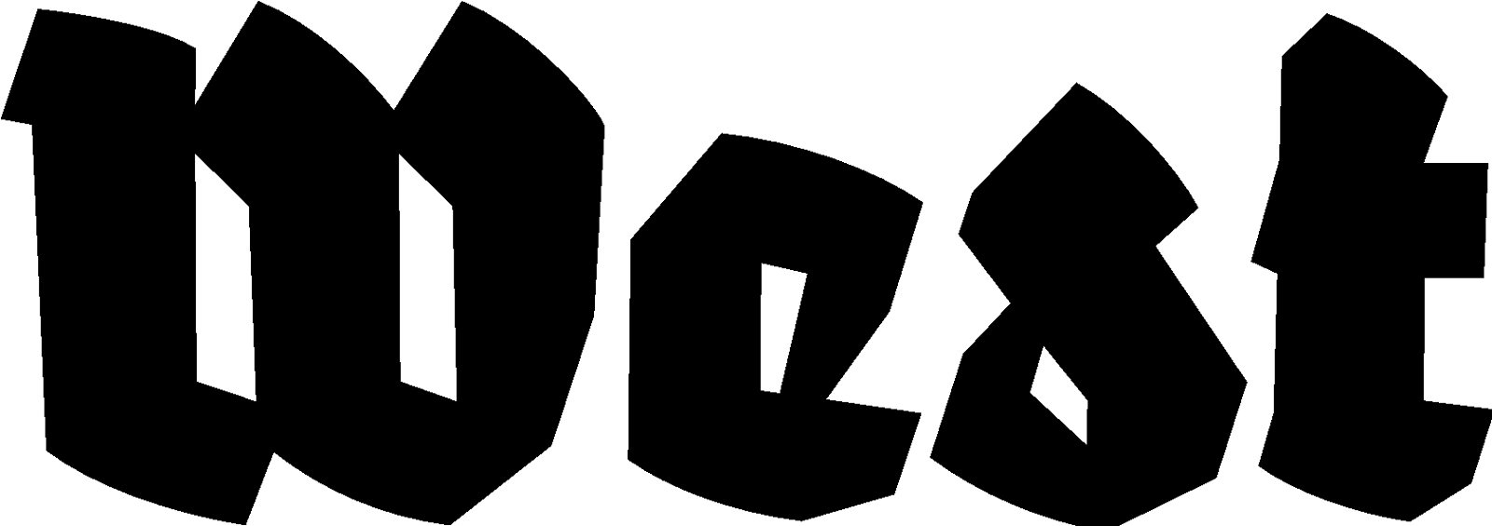

Press announcement 07.08.2024

BOILER ROOM
Charles van Otterdijk

Exhibition: 07.09.2024 — 10.11.2024 Opening: 07.09.2024, 20:00 hrs.
Location: West Den Haag in the form. American embassy, Lange Voorhout 102, The Hague

For his most recent project, ‘Boiler Room’ Charles van Otterdijk withdrew himself from the art world for years, to immerse himself in the world of Dutch drug laboratories. Now he returns for the first time with an installation around his extensive research into the illegal, and often dangerous production of synthetic drugs.

Synthetic drugs are produced on a large scale in the southern Netherlands. The province of southeast Brabant is also one of the greatest locations for research and production of the high-tech industry in Europe. According to conservative estimates by Tilburg University, the sales value of ecstasy and amphetamine produced in the Netherlands alone is at least as high as the annual turnover of the European tech company ASML.

The artist himself grew up in De Peel, on the border of the provinces North-Brabant and Limburg, known for its anabolic steroid laboratories, first for cattle and later for humans. The area is currently considered an important production site for xtc, and crystal meth is on the rise.

His new project began during the Trump era after the artist reread the still-urgent classic ‘Brave New World’ by Aldous Huxley. In the book, children are born and raised in laboratories, but a lab is also a place where recreational drugs, called ‘Soma’, are produced to keep the citizens peaceful and happy. Throughout the years, the artist visited various active drug laboratories. By accident, he discovered a place that turned out to be a training room where young people were schooled in drug production. At about the same time, Van Otterdijk read about a gang that had blown up many ATMs, mostly in Germany. When this gang, better known as the Audi gang after the type of getaway car the gang used, was busted, an instruction shed was discovered where people could practice ATM robberies. The shed was equipped with a real ATM, solely for this purpose. This ‘instruction lab’, which Van Otterdijk had seen by accident, became the guideline for his project. He shows photos that he managed to take in a still-producing drug laboratory, and lab equipment developed and produced by the artist himself. With these lab-elements, the artist could eventually open his own ‘instruction laboratory’ for the production of synthetic drugs. The first results are presented in West Den Haag.

Charles van Otterdijk previously retreated to the borders of ​​Germany, Poland, and the Czech Republic to investigate places where people had withdrawn from society. There he came across what he suspected to be an illegal military base. This resulted in the ‘Double Centre’ project (2009-2017), which was shown a.o. at Stroom, The Hague; Van Abbemuseum, Eindhoven; Künstlerhaus Bethanien, Berlin; Kaohsiung Museum of Fine Arts, Kaohsiung and Stedelijk Museum Bureau Amsterdam. Previous work was shown a.o. at NICC, Antwerpen; CIAP, Hasselt and TENT in Rotterdam.

For more information, please contact us: at info@westdenhaag.nl or +31(0)70.3925359

The program of West is made possible by a.o.: Municipality of The Hague and the Ministry of Education, Culture and Science.

